 | Towards the may isle
A  L  F  R  E  D | 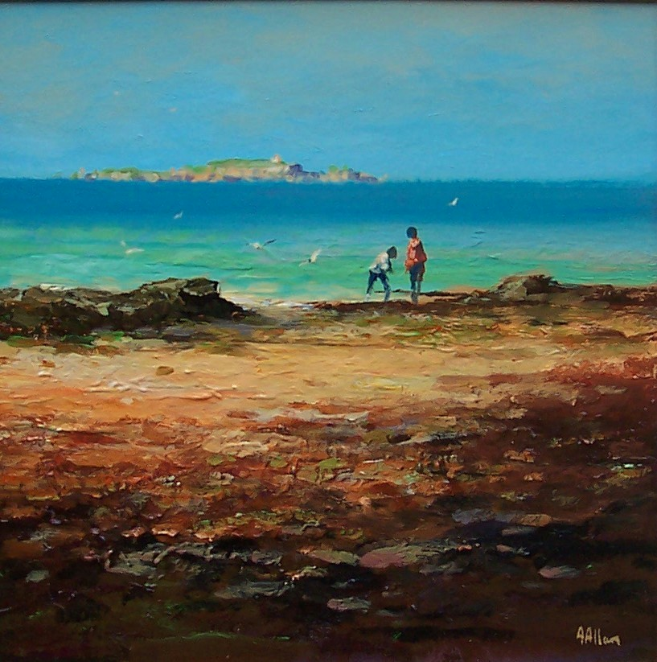 | A  L  L  A  N
Canvas Size – 16” x 16”
Medium – Acrylic
Price Framed - £850

