 | Summers day - elie
A  L  F  R  E  D | 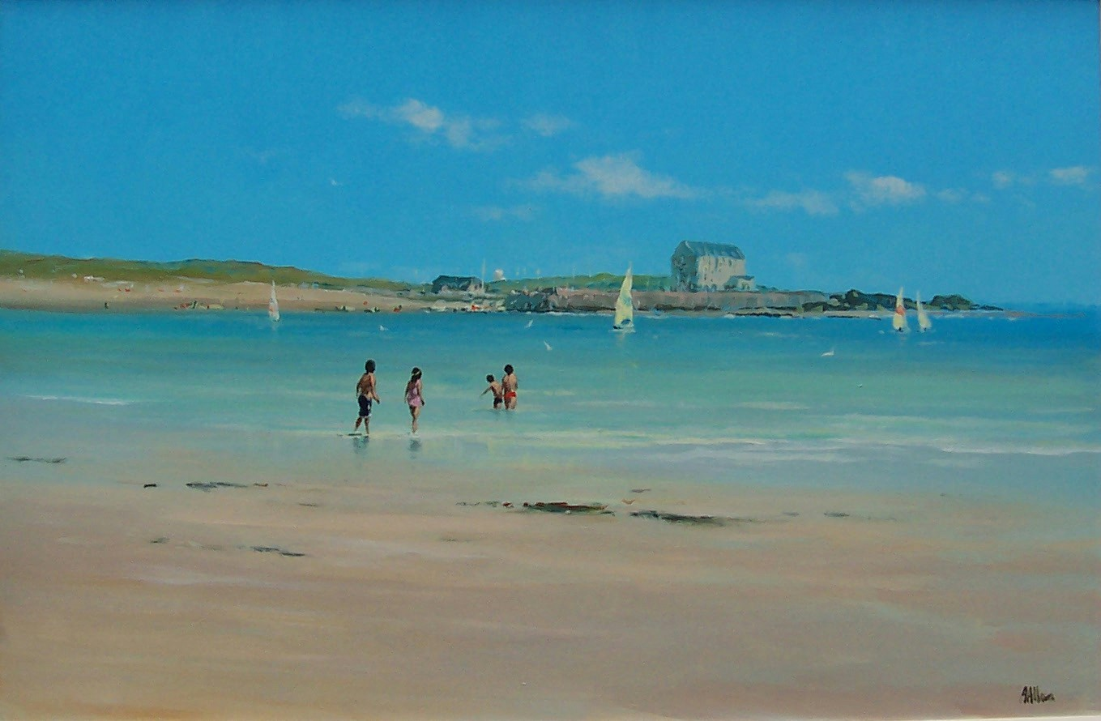 | A  L  L  A  N
Canvas Size – 30” x 20”
Medium – Acrylic
Price Framed - £1275

