 | Early morning over elie bay
A  L  F  R  E  D | 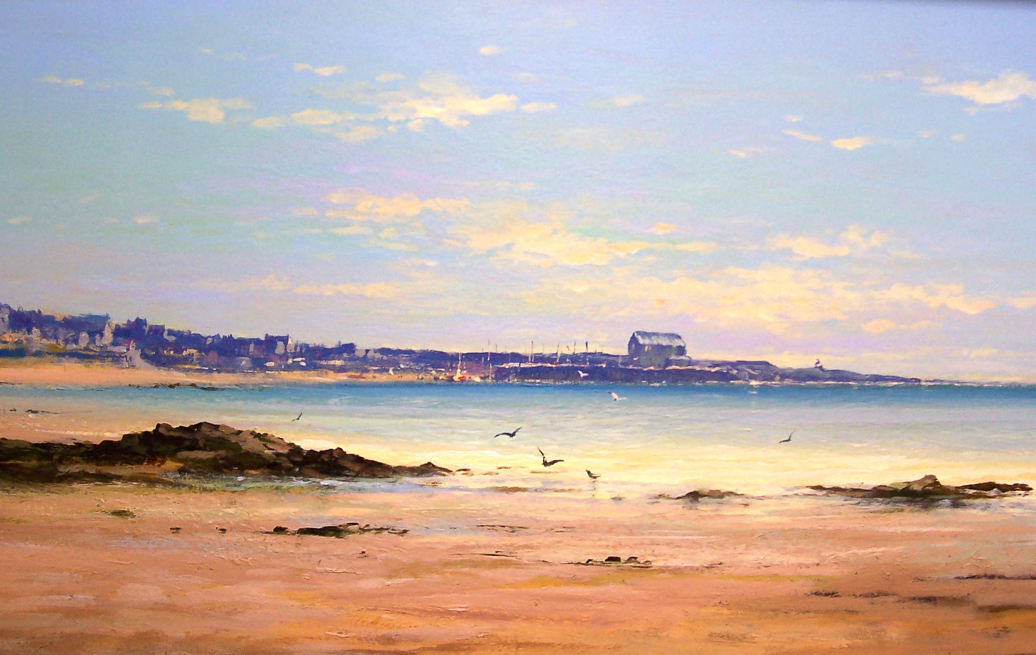 | A  L  L  A  N
Canvas Size – 36” x 24”
Medium – Acrylic
Price Framed - £1950

