 | WEST SHORE - PITTENWEEM
A  L  F  R  E  D | 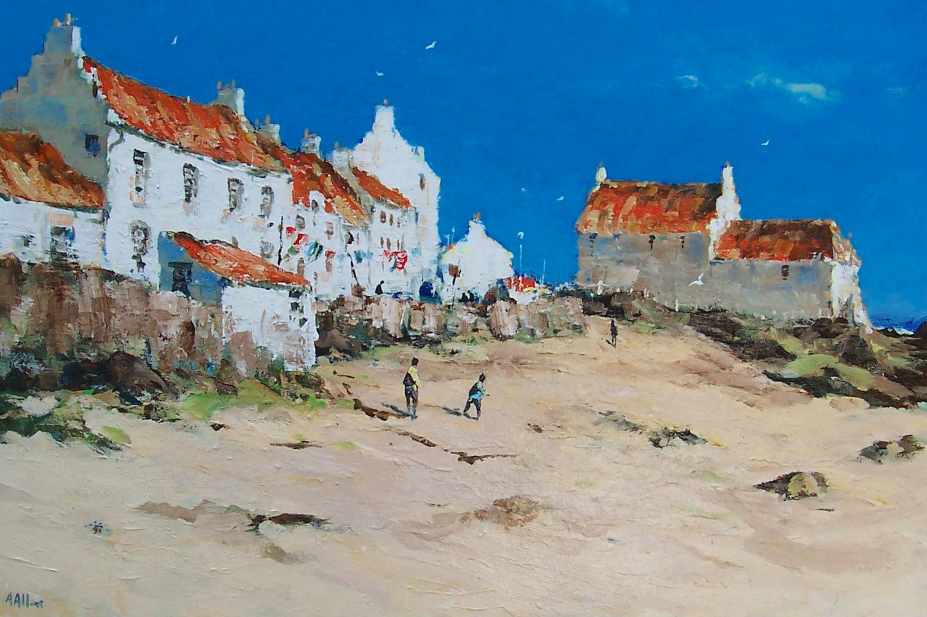 | A  L  L  A  N
Size – 30” x 24”
Medium – Acrylic

Price - £1750
SOLD

