 | Wash day –st.monans
A  L  F  R  E  D | 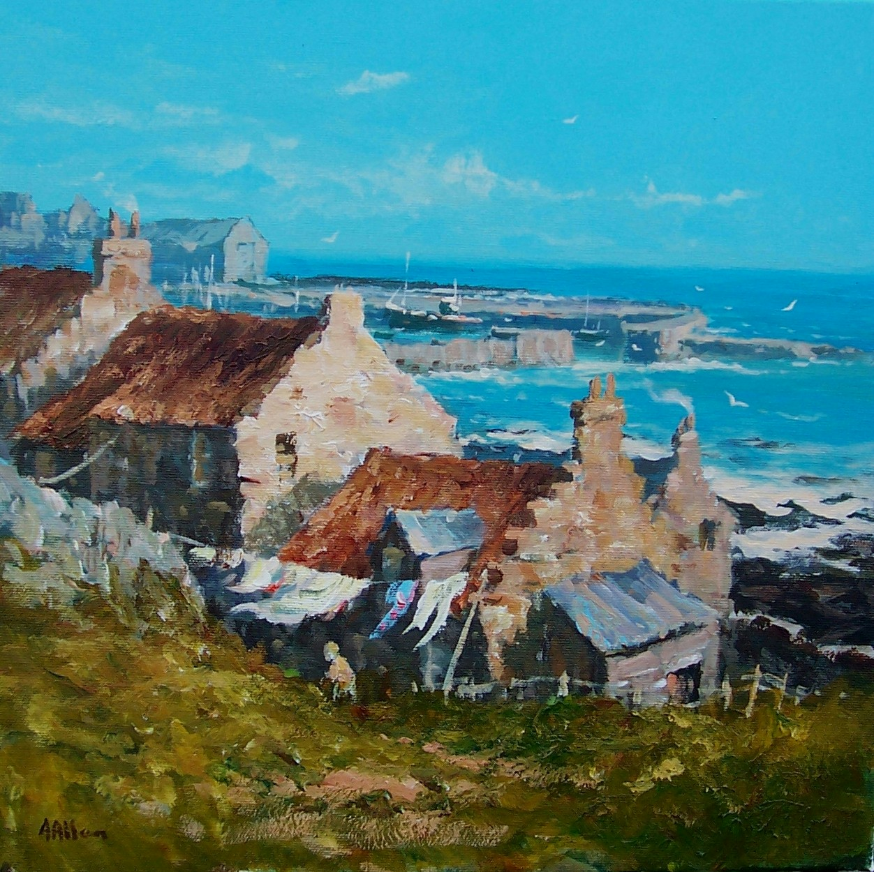 | A  L  L  A  N
Size – 16” x 16”
Medium - Acrylic
Price - £425
SOLD

