 | Towards the granary
A  L  F  R  E  D | 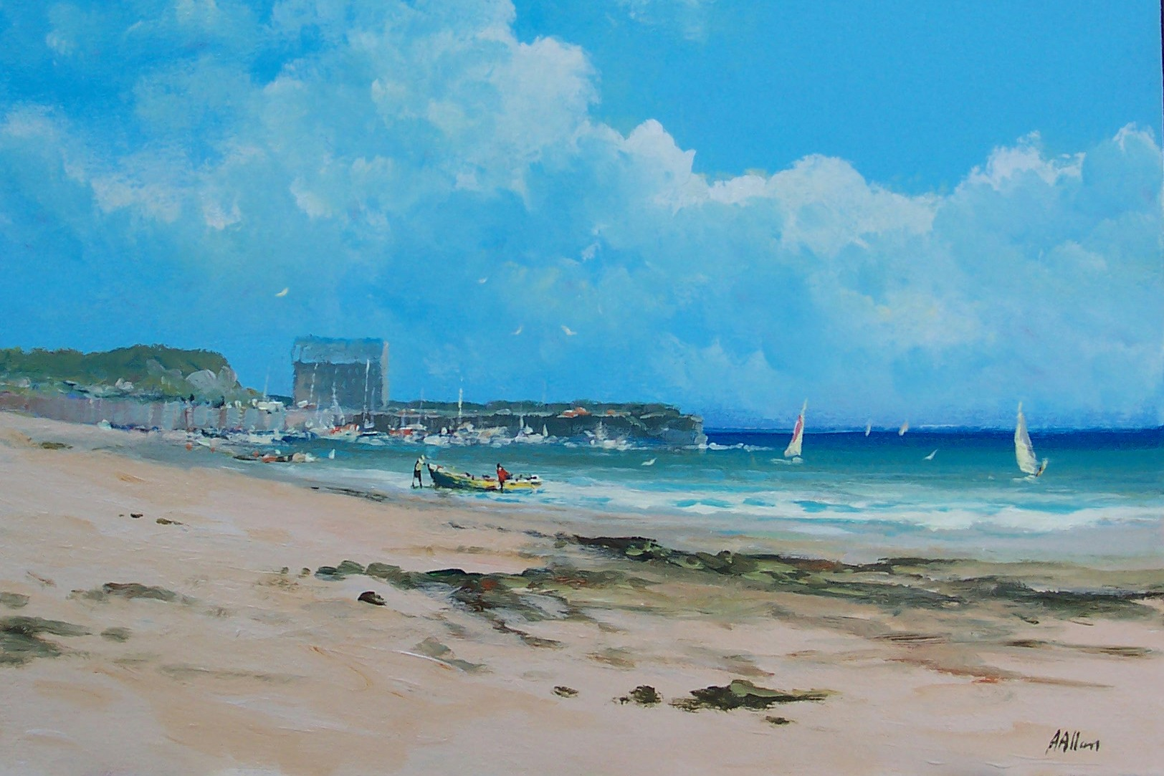 | A  L  L  A  N
Size 30” x 20”
Medium – Acrylic
Price - £1500
SOLD

