 | sutherland
A  L  F  R  E  D | 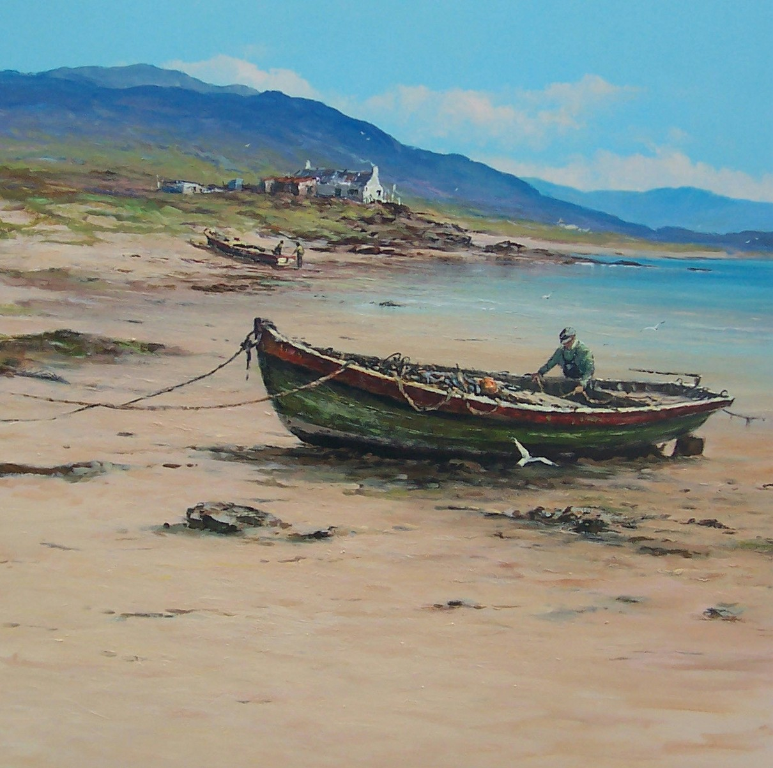 | A  L  L  A  N
Size – 40”x 40”
Medium - Acrylic
Price - £3250
SOLD

