 | Setting sail- elie
A  L  F  R  E  D | 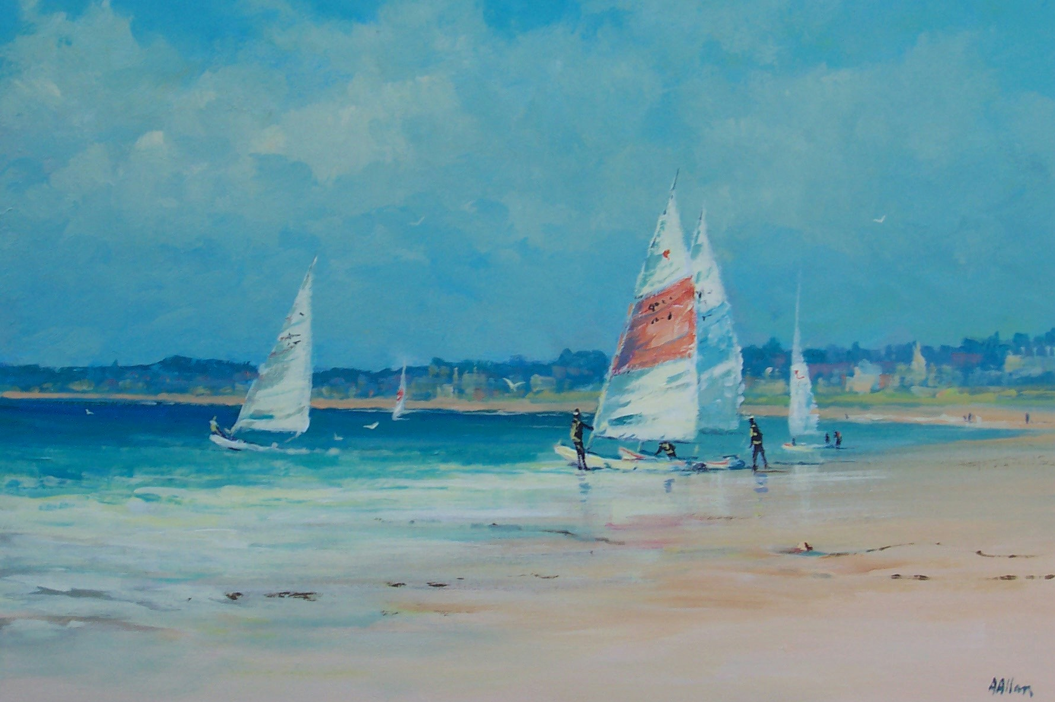 | A  L  L  A  N
Size- 16”x 20”

Medium – Acrylic

Price - £795

SOLD

