 | Paddling - Elie Bay
A  L  F  R  E  D | 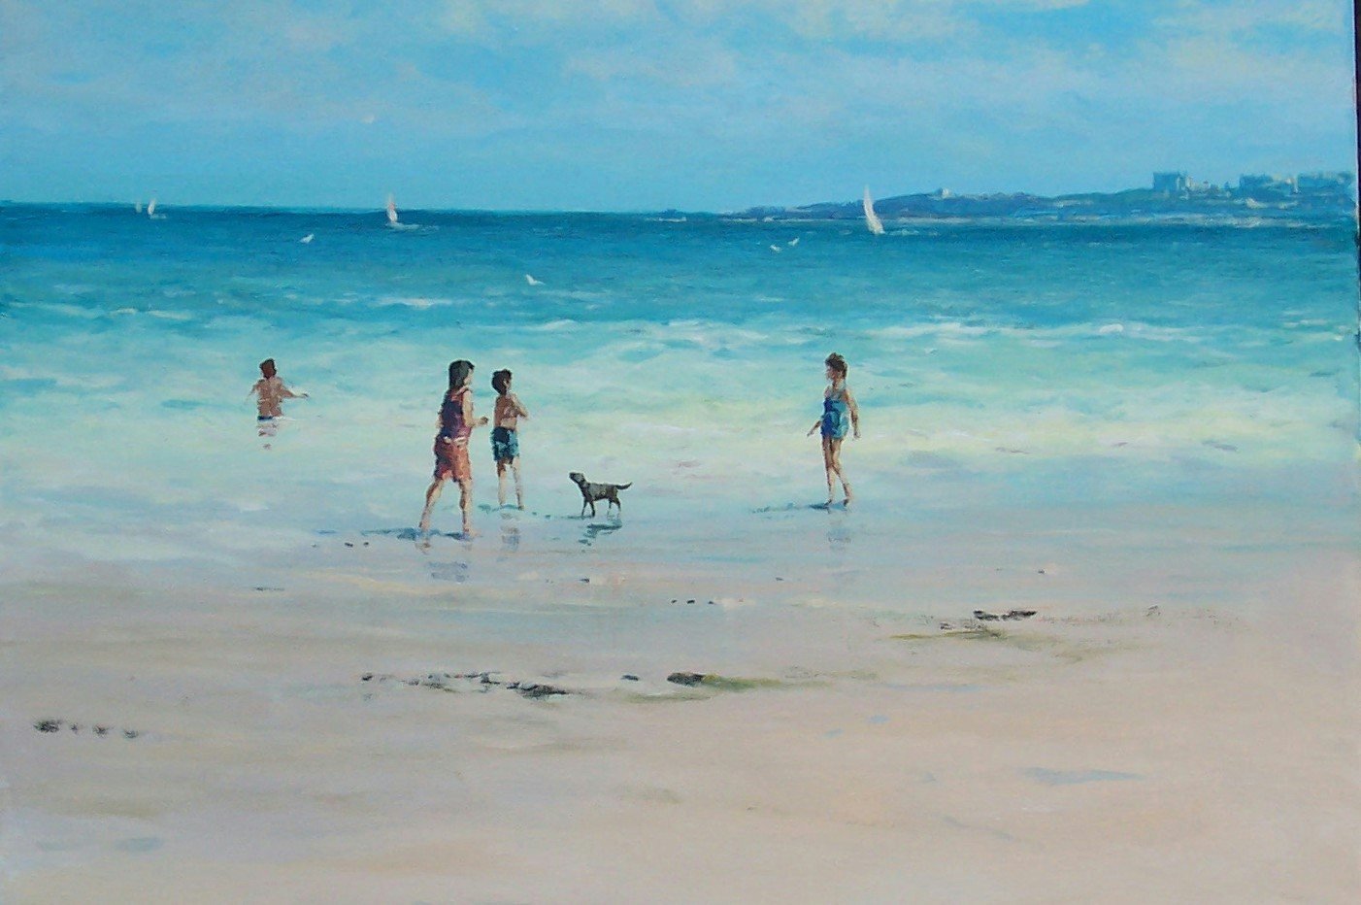 | A  L  L  A  N
Size – 16” x 20”
Medium - Acrylic
Price - £850
SOLD

