MORNING HAZE - CRAIL
A  L  F  R  E  D | 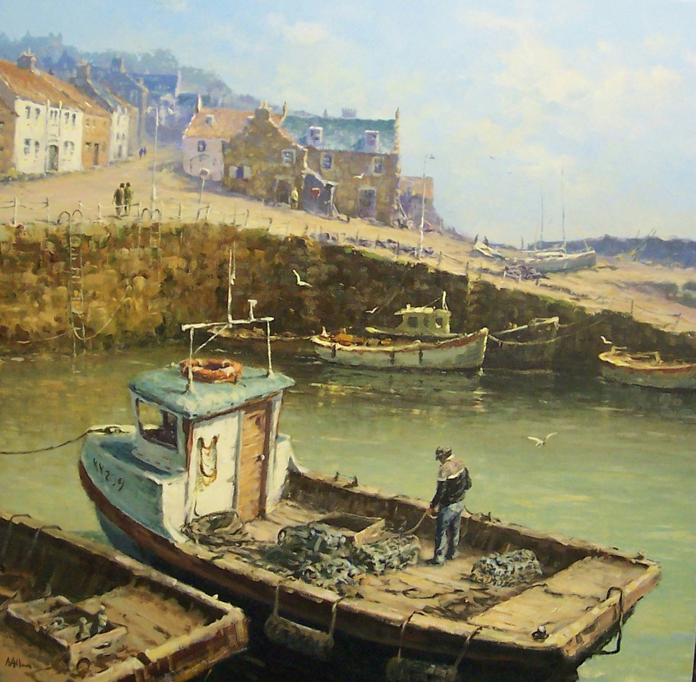 | A  L  L  A  N
Size – 36” x 36”

Medium -Acrylic
Price - £2750

SOLD

