 | Lone yachtsman
A  L  F  R  E  D | 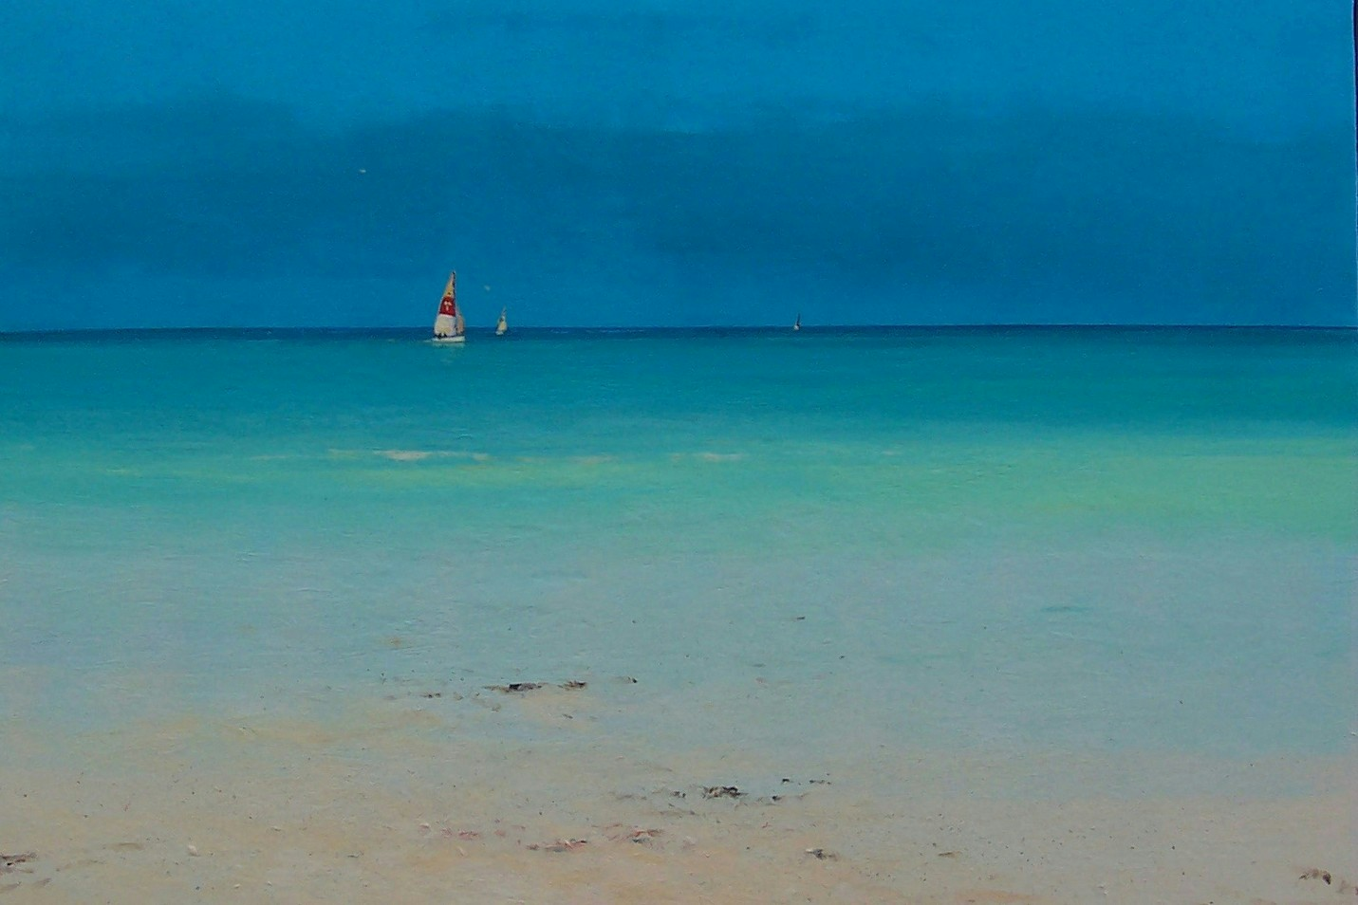 | A  L  L  A  N
Size – 12” x 10”
Medium – Acrylic
Price - £425

