 | golf course earlsferry
A  L  F  R  E  D | 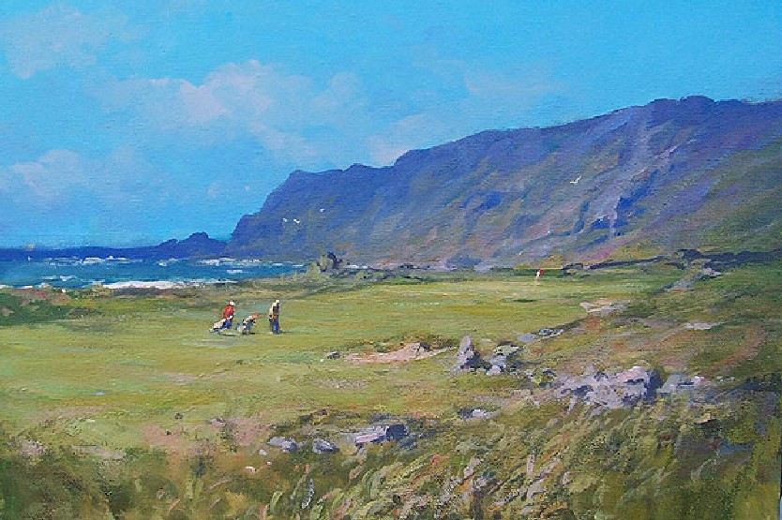 | A  L  L  A  N
Size- 36” x 24”
Medium – Acrylic
Price - £1975
SOLD

