 | Final rays – st. andrews
A  L  F  R  E  D | 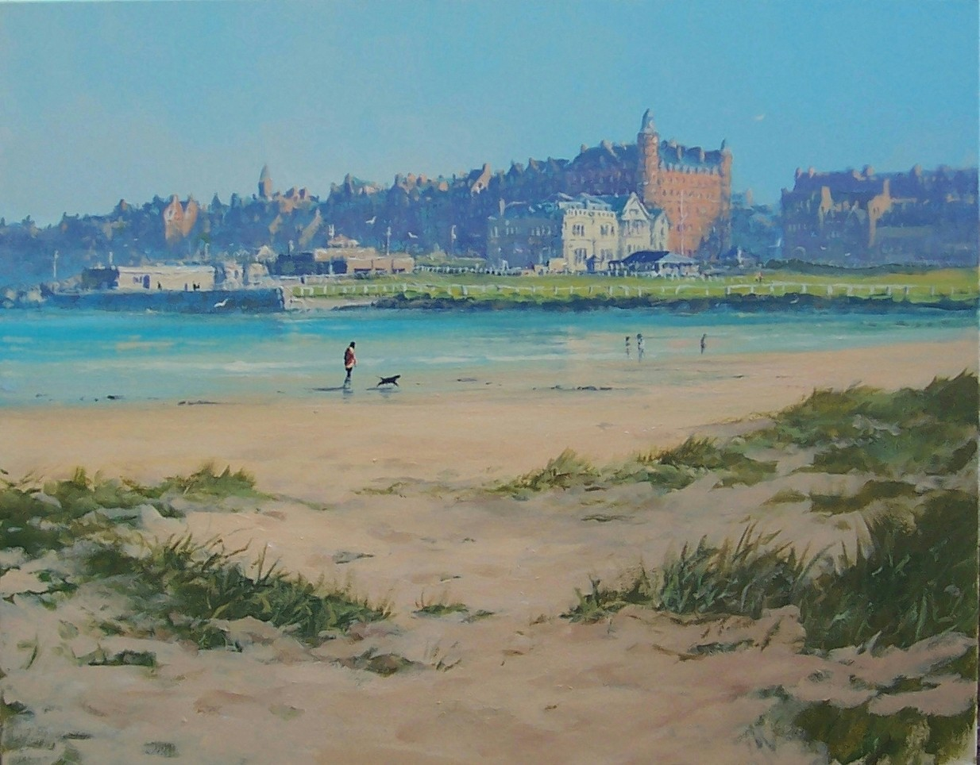 | A  L  L  A  N
Size – 40” x 30”
Medium – Acrylic
Price - £2500
SOLD

