 | FIGURES ON THE BEACH
A  L  F  R  E  D | 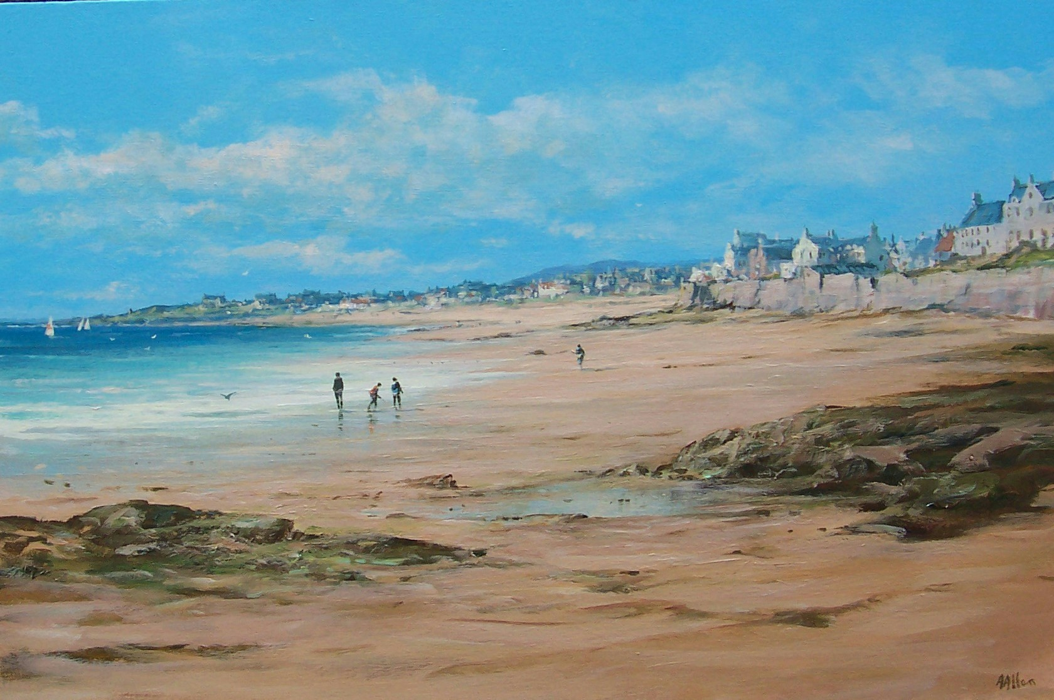 | A  L  L  A  N
Size – 30” x 24”
Medium - Acrylic
Price - £1795
SOLD

