Evening sun - crail
A  L  F  R  E  D | 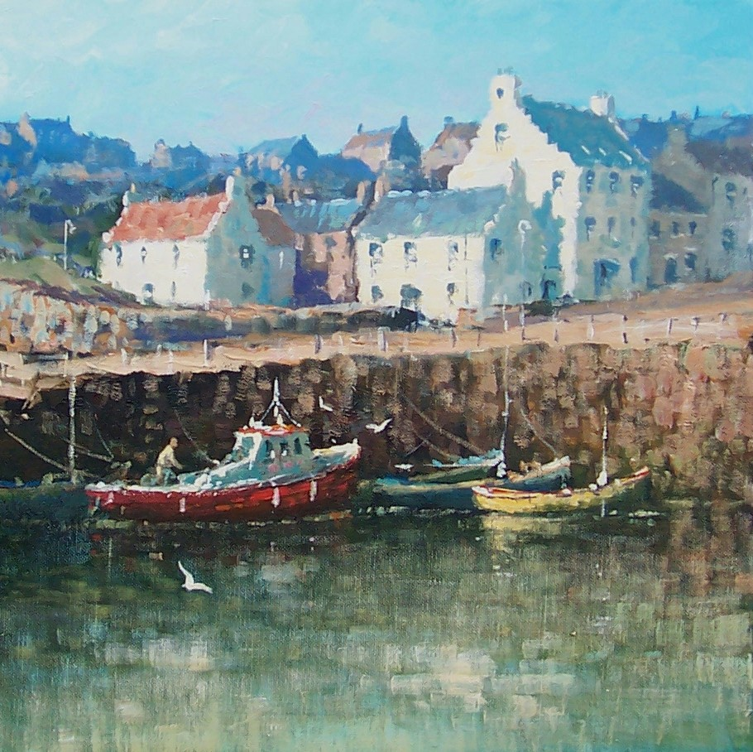 | A  L  L  A  N
Size – 20” x 20”
Medium - Acrylic

