 | Enjoying the view -glencoe
A  L  F  R  E  D | 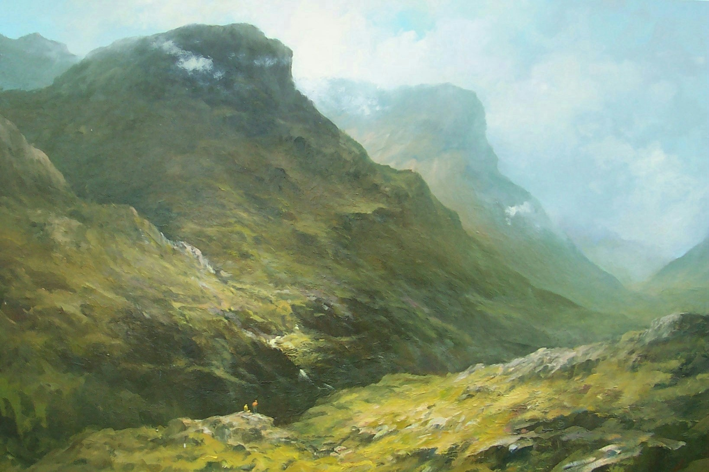 | A  L  L  A  N
Size – 40”x 40”
Medium - Oils
Price - £2500
SOLD

