 | Elie bay
A  L  F  R  E  D | 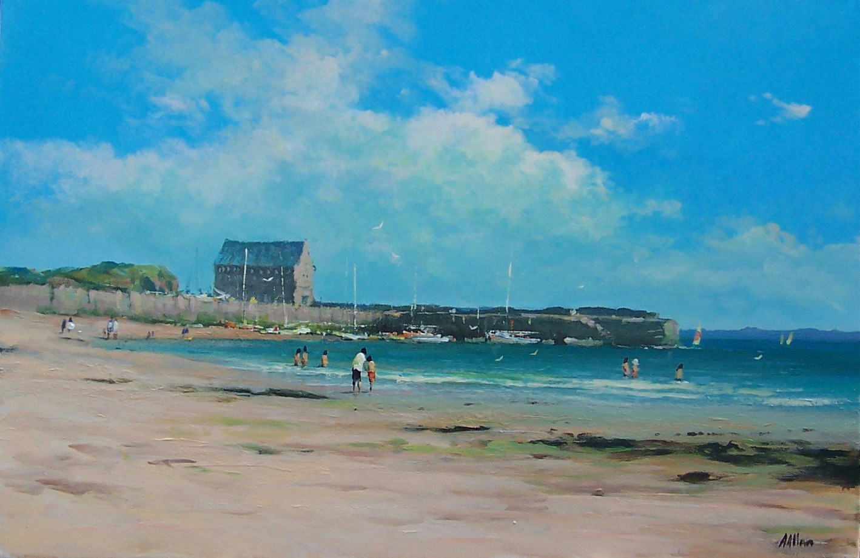 | a  L  L  A  N
Size – 16”x 20”
Medium – Acrylic
Price - £525
SOLD

