 | Early morning - elie
A  L  F  R  E  D | 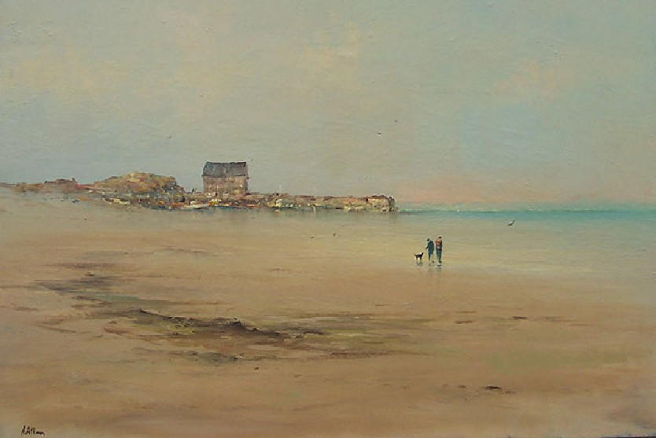 | a  L  L  A  N
Size – 30” x 40”
Medium – Acrylic
Price - £2750
SOLD

