 | ENJOYING THE SUMMER
A  L  F  R  E  D | 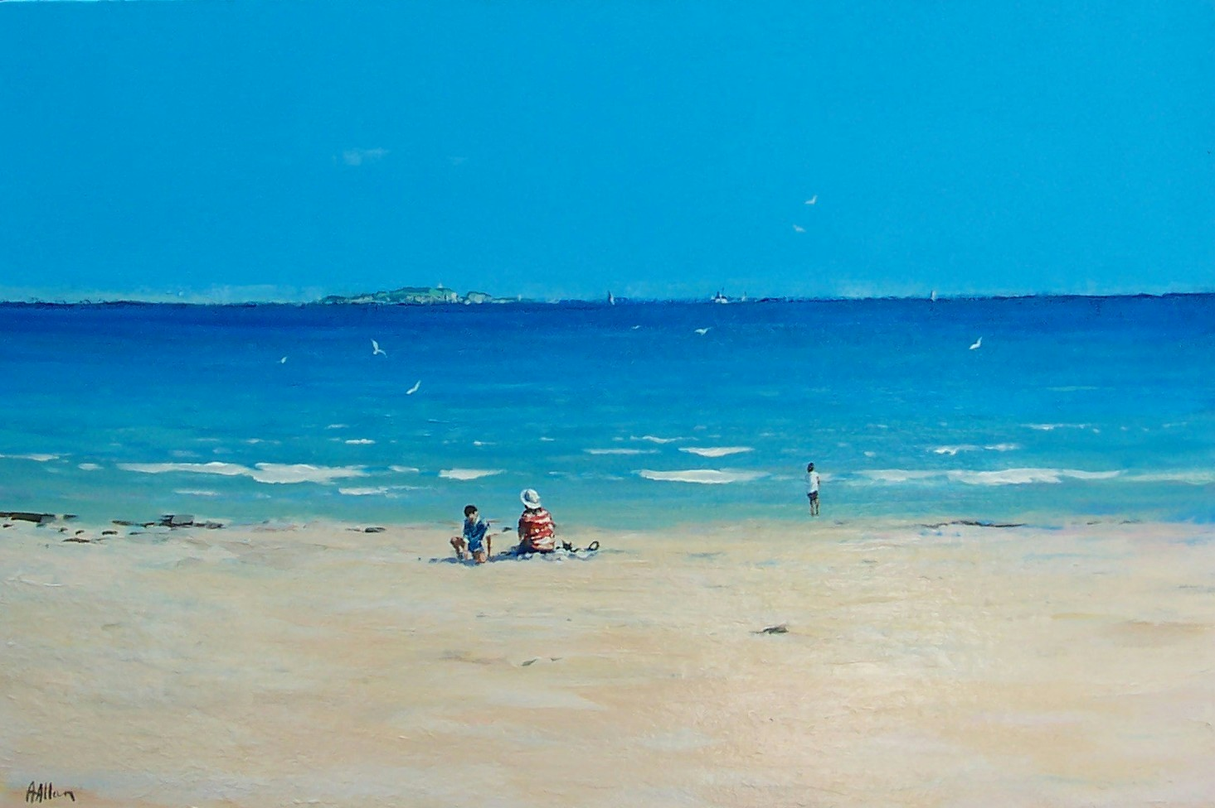 | A  L  L  A  N

Size - 30” x 24”
Medium - Acrylic
Price - £1650

