 | Club house- st.andrews
A  L  F  R  E  D | 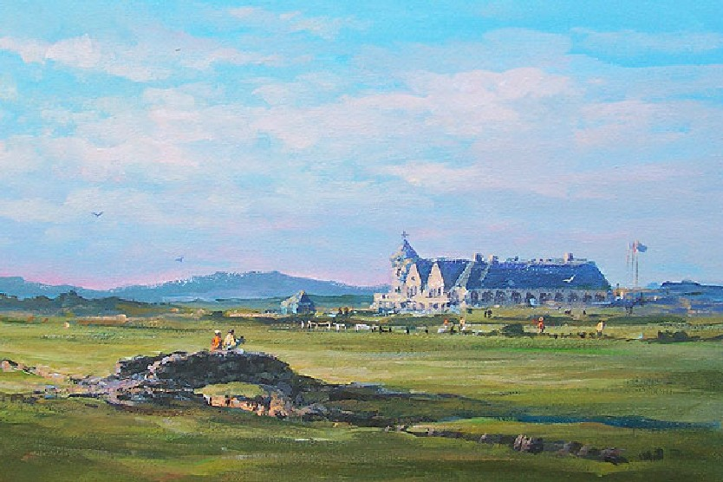 | A  L  L  A  n

SIZE – 12” X 16”

Medium – Acrylic
Price - £625

SOLD

