 | BOATS AT PITTENWEEM
A  L  F  R  E  D | 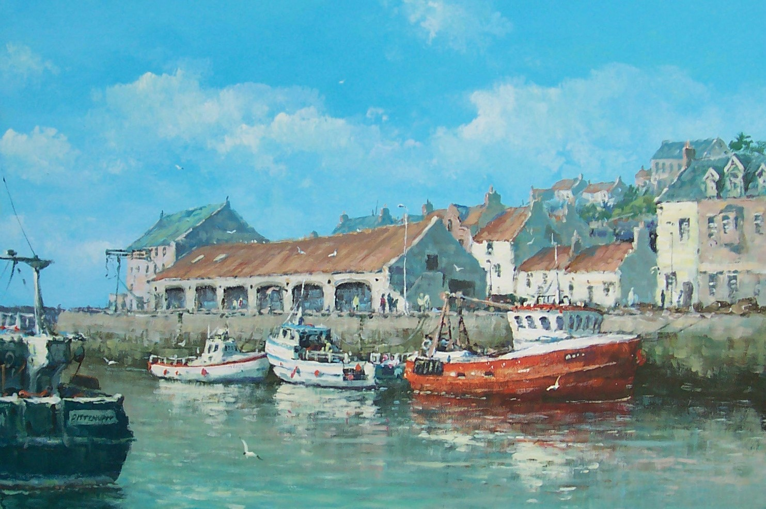 | A  L  L  A  N
Size – 36” x 24”
Medium – Acrylic
Price _ £1975

