 | BEACH AT EARLSFERRY
A  L  F  R  E  D | 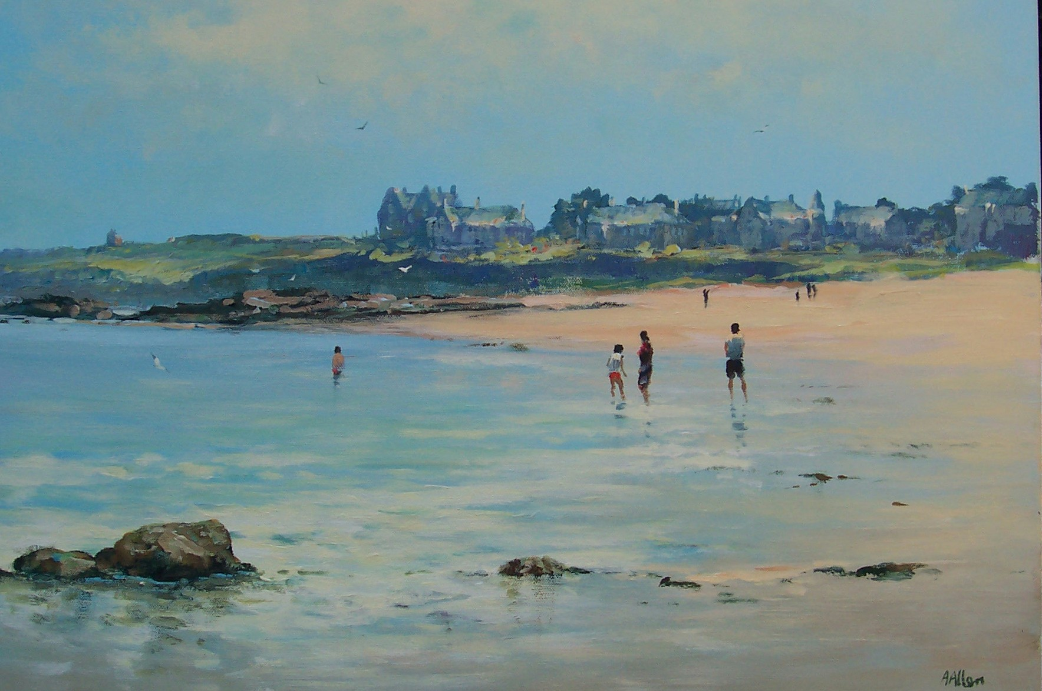 | A  L  L  A  N
Size – 30” x 24”
Medium – Acrylic
Price- £1625

