 | A COOLER DAY
A  L  F  R  E  D | 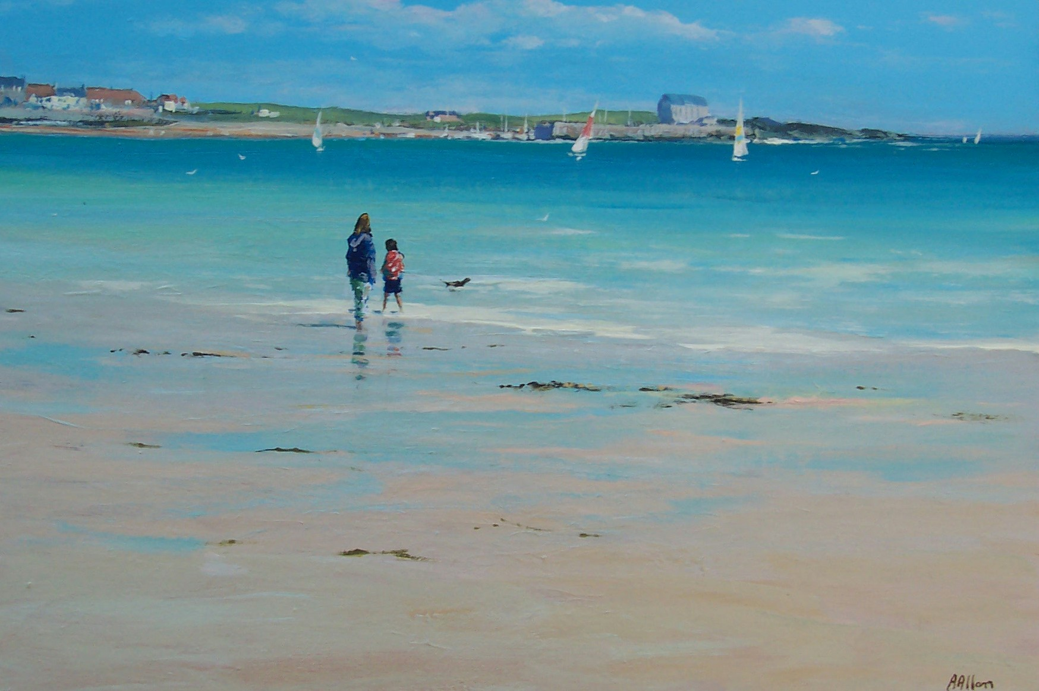 | A  L  L  A  N
Size - 30” X 20”
Medium – Acrylic
Price - £1500

